June 6-2020

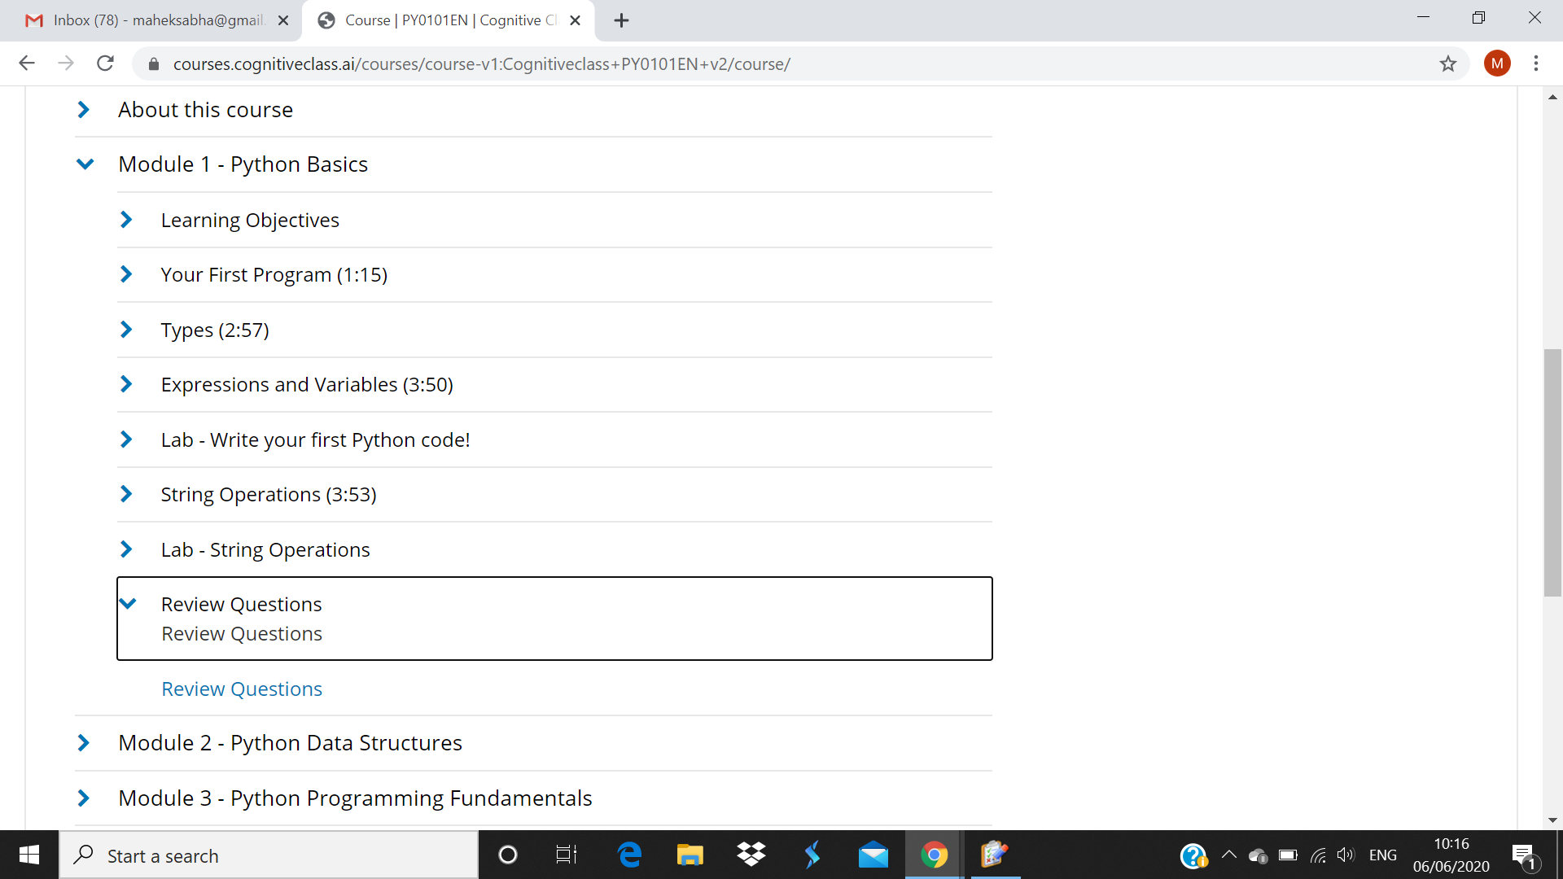

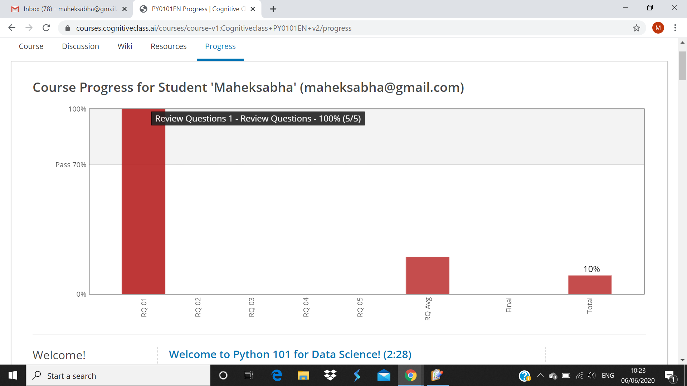

I solved the review question on module 1 and above screenshot is the progress of 1st module .